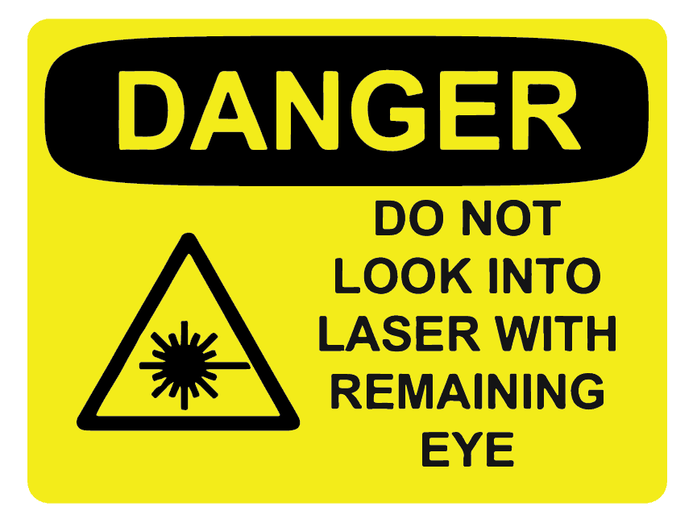

Laser Cave

**PLEASE DO NOT TOUCH**Remove by 5/14/21